Exercise: Given *numRows*, generate first rows of Pascal’s Triangle.

In Pascal triangle, the first and the second rows are set to 1. Each element of the triangle (from the third row downward) is the sum of the element directly above it and the element to the left of the element directly above it.

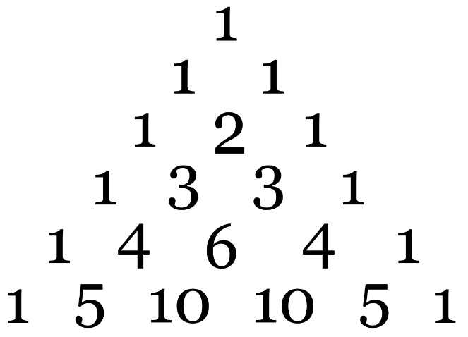

https://en.wikipedia.org/wiki/Pascal%27s_triangle